

#### 16x20mm Coreless Brushed Series

**SPECIFICATIONS:**

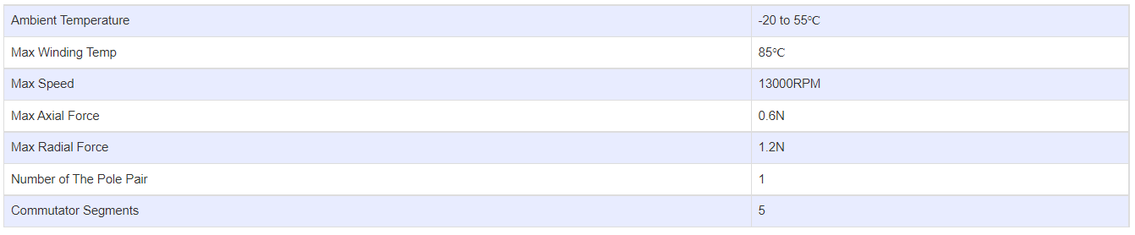

**SUBMODELS:**

*The following are common submodels for the LDO-CL1620 series.*

